Ballistic Missile Program Notes
Christopher Kalitin

June 17 2025
Going to take notes that aren’t in comments.

https://chatgpt.com/c/685250f7-cee8-8006-b6ef-bcfcd3f8f0fa

Unity treats all child colliders as a single compound collider of a parent object.
Will need to manually recalculate mass and center of mass though.
rb.ResetInertiaTensor(); recomputes from colliders and CoM, useful for staging
Looks like Unity is making me use Rigidbodies, not bad and I can also add some way to write custom flight control software.

I guess I’m accidentally making a space simulator, oops

I’ve actually never been writing good Unity code my god imagine if ChatGPT was available when I was doing all of this. I was right to be so nervous about not integrating AI into my Unity workflow this is so much better. It really does make mid devs way better, but not 10x engineers because that’s architecture.

Already feeling the tech debt and nothing has even been run yet.

Todo:
- Refactor vehicle blueprint. ChatGPT didn’t use attach points at all.
  - Flatten part field with parent ID, no need to be especially human readable it’ll never be edited like that except by me.
  - Make both attach points filled on each object
  - you need to know which on the child you’re using too
- Refactor decoupling and stage number so it’s all based on a decoupling behaviour script on a decoupler object.
- Refactor mass (resource mass and dry mass) also figure out resource mass fields (keep in standard behaviour class and set in a list in part instance?)
- Fuck it make it 3D I want to see the trees explode.
- Refactor so I understand it all (IReadOnlyList??)
- Refactor comments too

Ideas:
- Engine editor (engine parts strung together just like vehicles, but with more specific parameters like shaft strength, preburner power, chemistry, etc.)
- Avionics editor (same thing but power, antenna, computation, sensors, etc.)

Todo:
- Flatten part field with parent ID, no need to be especially human readable it’ll never be edited like that except by me

June 22 2025
Holy shit it’s been straight Solar for how long??

I finished all todo’s from last time and am now getting somewhere.

Getting mass and CoM correct was tough probably because it’s 2am now.

Going forward, I need thrust and camera and vehicle editor. Only three required things.

- Thrust
  - User control of thrust vector and throttle
  - Fuel drain from stage (select tanks? All on stage or all on vehicle)
- User controlled camera and follow rocket camera (chase or point towards with zoom of course)
- Vehicle editor UI - click on parts and select children?

Start recording for a Youtube Video, I’ve got the storage for it

Model the UI after this:
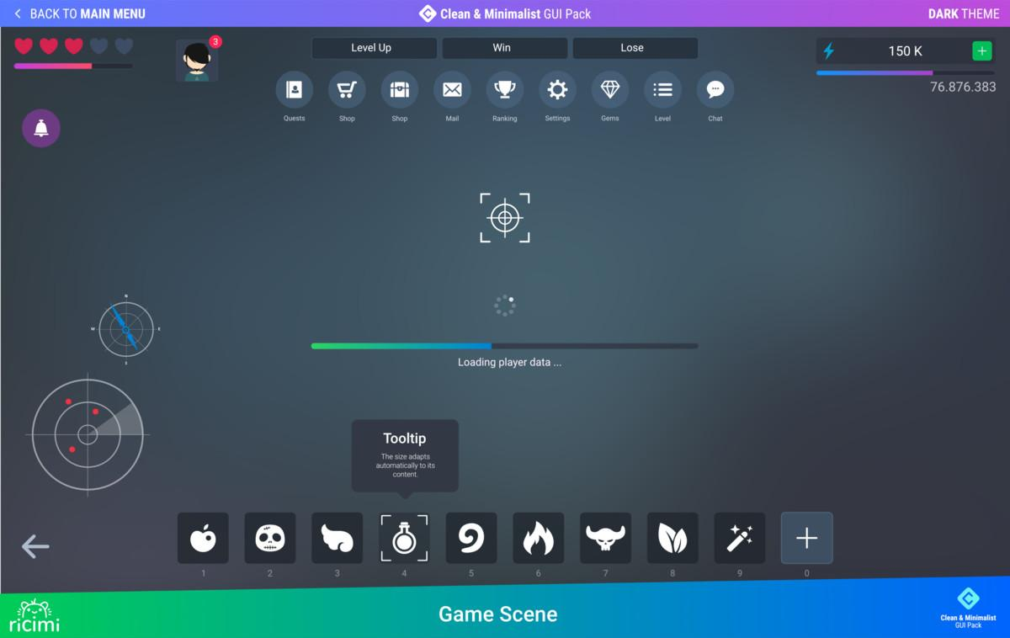
Notice the gradient idk how to do that, maybe just buttons

Tech tree and contracts:
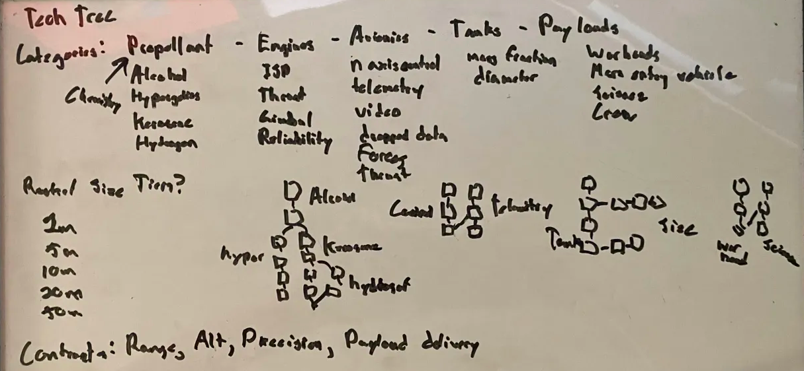

June 23 2025
I got explosions, lot of shitty code to get this to work. Eg. need a refactor or detaching vehicles into sub vehicles.

Also required is lift and drag later. First, camera. Then, lift. Then, user control of the rocket and active parts (staging). Then, vehicle editor. Then, everything else.

I need to get rid of the user control stuff and make an automated flight profile script I’ve been working in the wrong direction for the gameplay I want.

